module vat_buzzer_behavior ( output buzzer,

input above_25_0, above_30_0, low_level_0,

input above_25_1, above_30_1, low_level_1,

input select_vat_1 );

assign buzzer = select_vat_1 ? low_level_1 | (above_30_1 | ~above_25_1)

: low_level_0 | (above_30_0 | ~above_25_0);

Endmodule

module tb_vat_buzzer_behavior();

wire buzzer;

reg above_25_0;

reg above_25_1;

reg above_30_0;

reg above_30_1;

reg low_level_0;

reg low_level_1;

reg select_vat_1;

integer i;

vat_buzzer_behavior UUT(buzzer, above_25_0, above_30_0, low_level_0, above_25_1, above_30_1, low_level_1, select_vat_1 );

initial

begin

$monitor("buzzer = ", buzzer, "above_25_0 = ", above_25_0, "above_25_1 = ", above_25_1, "

above_30_0 = ", above_30_0, "above_30_1 = ", above_30_1, "low_level_0 = ", low_level_0, "low_level_1 = ", low_level_1, "select_vat_1 = ",select_vat_1);

for(i=0; i<=15; i=i+1)

begin

above_25_0 = $urandom%2;

above_25_1 = $urandom%2;

above_30_0 = $urandom%2;

above_30_1 = $urandom%2;

low_level_0= $urandom%2;

low_level_1= $urandom%2;

select_vat_1=$urandom%2;

#10;

end

end

endmodule

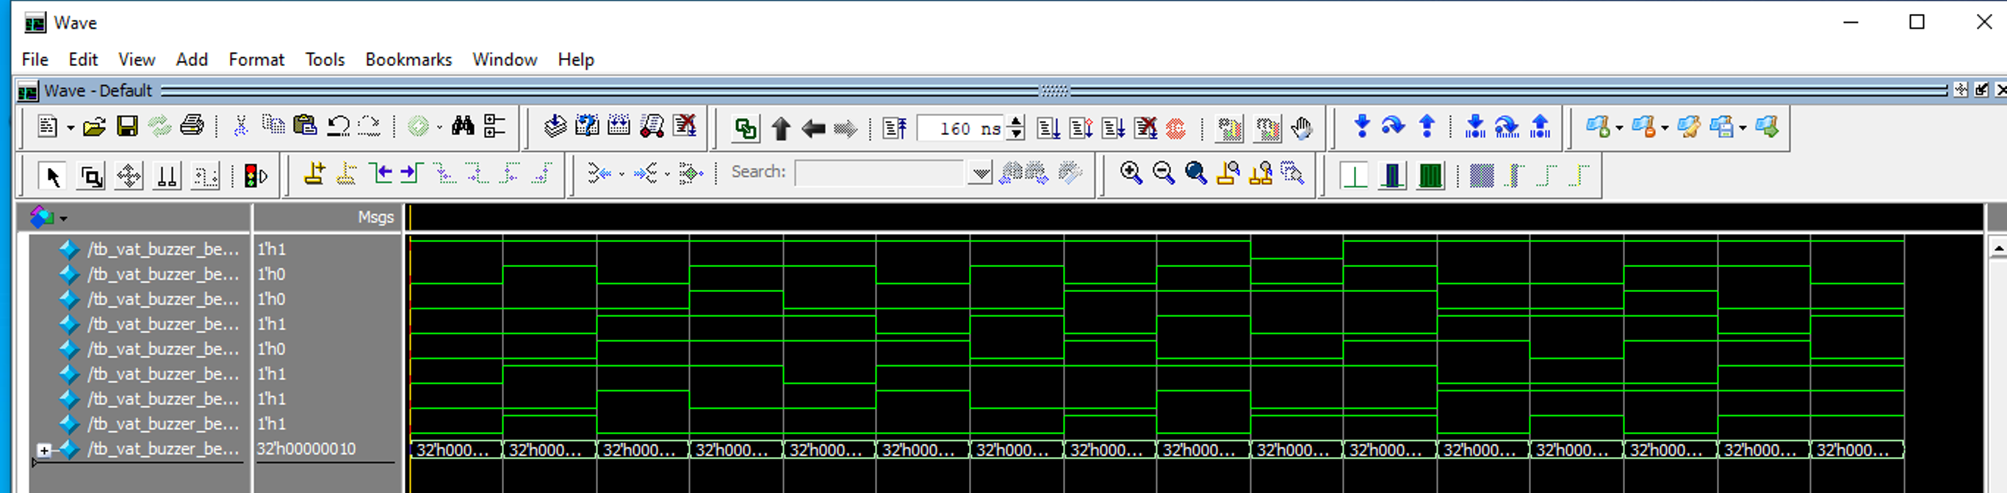

module alarm_priority ( output [2:0] intruder_zone,

output valid,

input [1:8] zone );

wire [1:8] winner;

assign winner[1] = zone[1];

assign winner[2] = zone[2] & ~zone[1];

assign winner[3] = zone[3] & ~(zone[2] | zone[1]);

assign winner[4] = zone[4] & ~(zone[3] | zone[2] | zone[1]);

assign winner[5] = zone[5] & ~(zone[4] | zone[3] | zone[2] |

zone[1]);

assign winner[6] = zone[6] & ~(zone[5] | zone[4] | zone[3] |

zone[2] | zone[1]);

assign winner[7] = zone[7] & ~(zone[6] | zone[5] | zone[4] |

zone[3] | zone[2] | zone[1]);

assign winner[8] = zone[8] & ~(zone[7] | zone[6] | zone[5] |

zone[4] | zone[3] | zone[2] |

zone[1]);

assign intruder_zone[2] = winner[5] | winner[6] |

winner[7] | winner[8];

assign intruder_zone[1] = winner[3] | winner[4] |

winner[7] | winner[8];

assign intruder_zone[0] = winner[2] | winner[4] |

winner[6] | winner[8];

assign valid = zone[1] | zone[2] | zone[3] | zone[4] |

zone[5] | zone[6] | zone[7] | zone[8];

endmodule

module tb_alarm_priority();

reg[1:8] zone;

wire[2:0] intruder_zone;

wire valid;

integer i;

alarm_priority UUT(intruder_zone, valid, zone);

initial

begin

$monitor("intruder_zone = %b", intruder_zone, "valid = ", valid, "zone = %b", zone);

for (i=0; i<=15; i=i+1)

begin

zone=$urandom%2**8;

#10;

$display("\n\n");

end

end

endmodule

